25 - EF Assignment-DOTNET

1. Application to create tweeter clone
2. Login Form

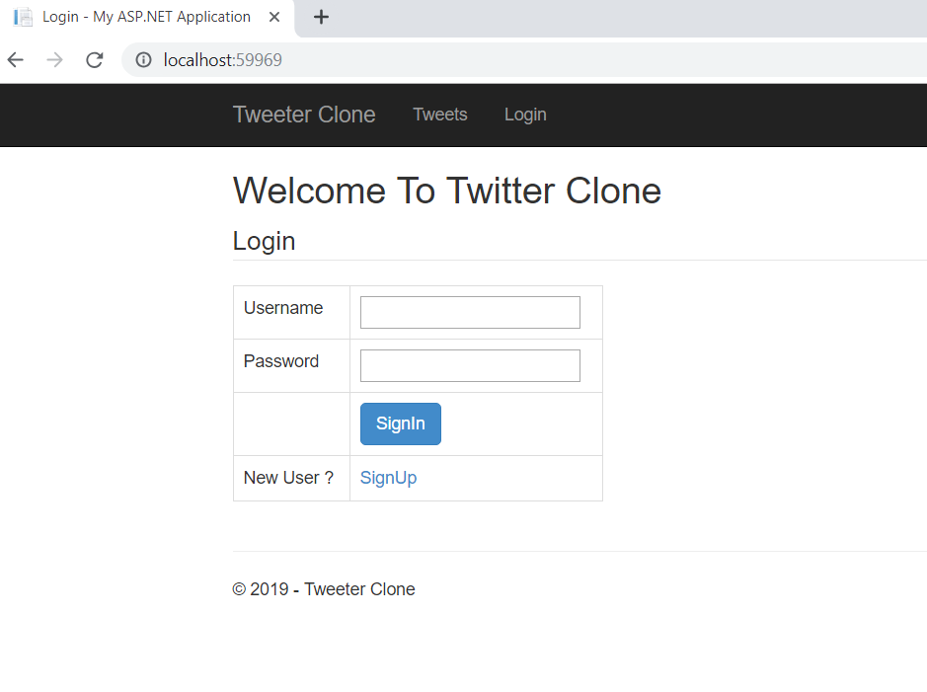

1. User Creation

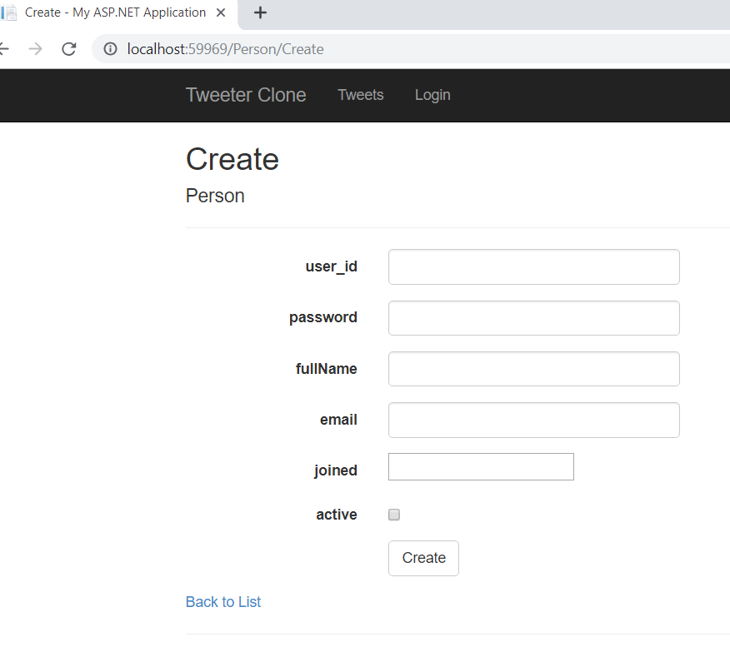

public ActionResult Create([Bind(Include = "user_id,password,fullname,email,joined,active")] Person person)

{

if (ModelState.IsValid)

{

db.People.Add(person);

db.SaveChanges();

return RedirectToAction("Index");

}

return View(person);

}

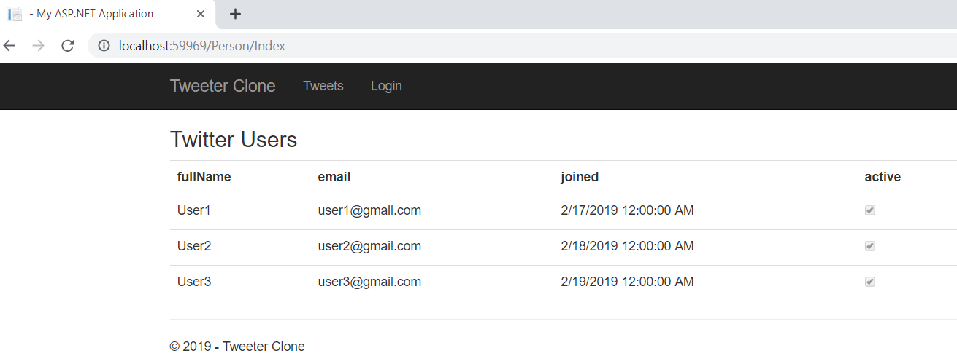

1. Tweet Home page

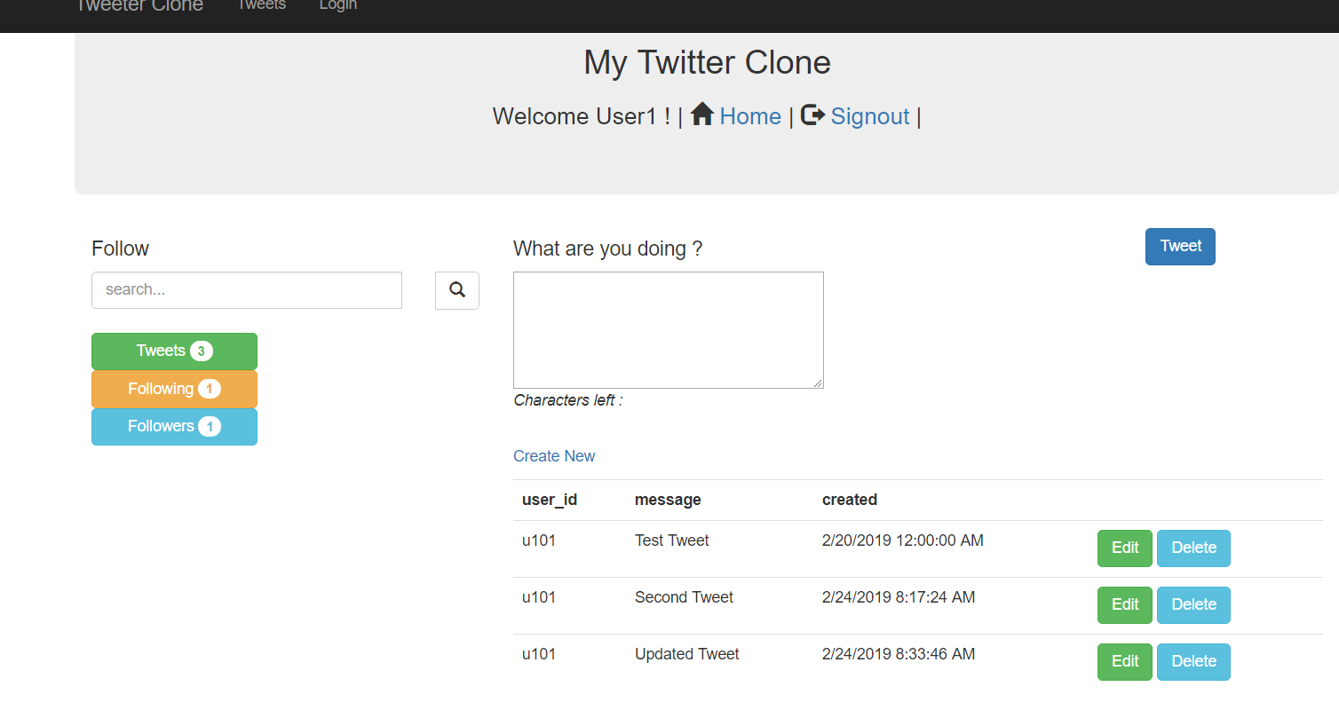

1. Create new Tweet

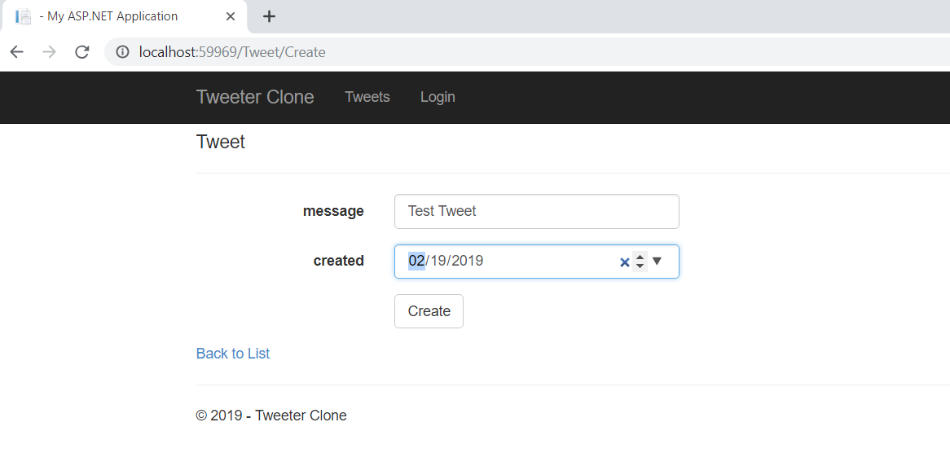

1. Update Tweet

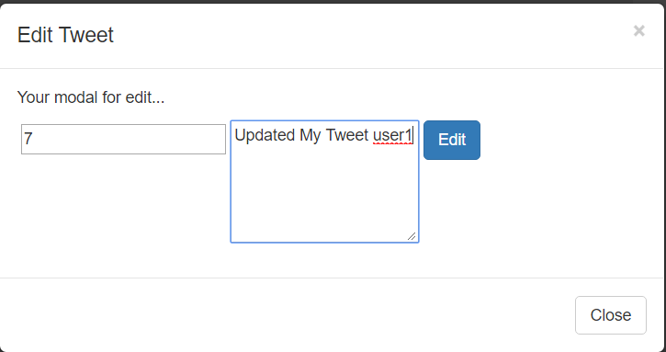

After update tweet

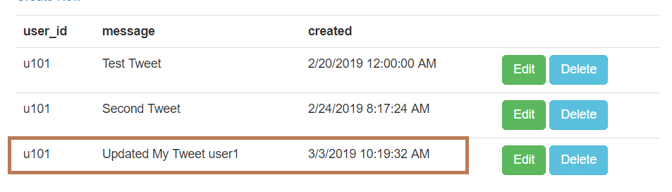

1. Delete Tweet – After deleting Tweet (Note: confirmation message or new view is not added for delete tweets)

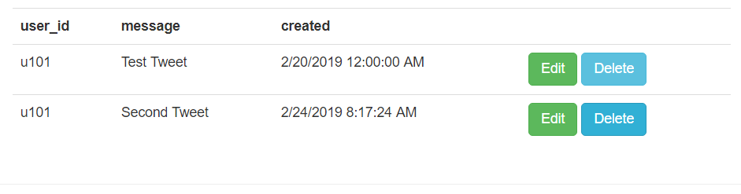

1. Follow users –

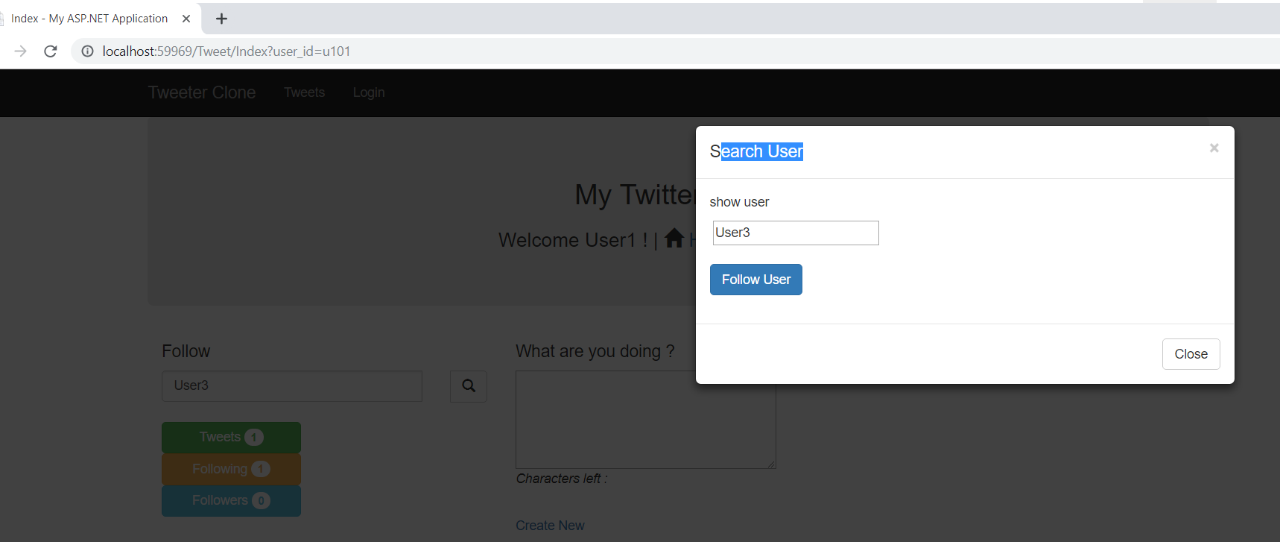

1. Display number of tweets, followers and followings

